WACE 2014

The diagram below illustrates a cell organelle. Use this diagram to answer parts (a) and (b) below.

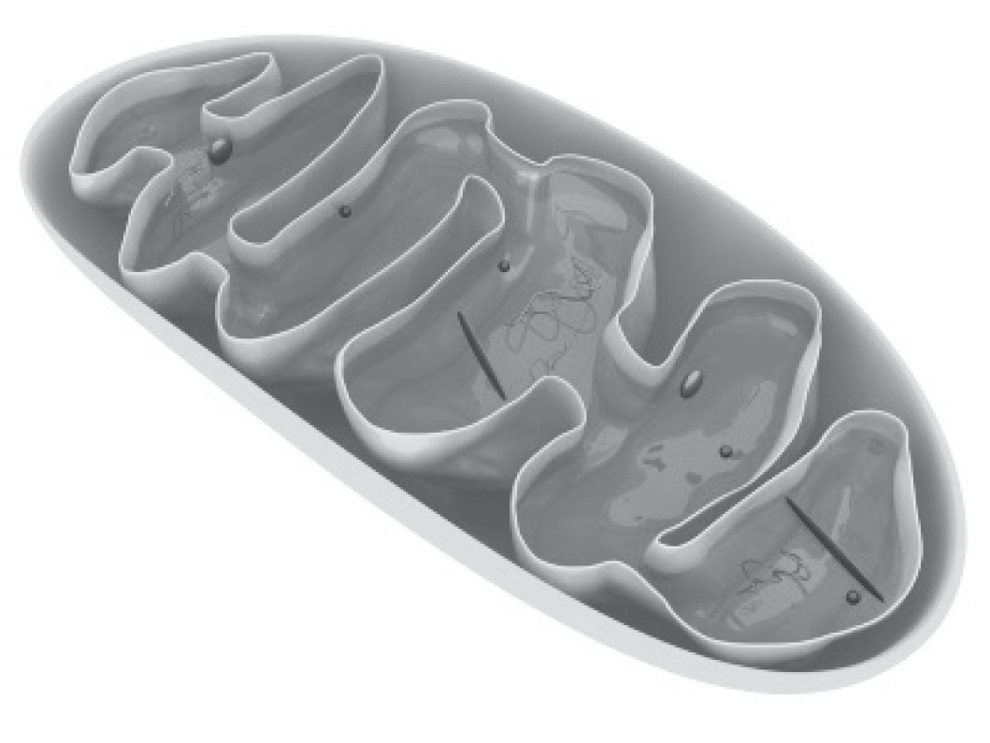

1. (i) Name this cell organelle. (1 mark)
2. Name the process that occurs in this organelle to produce energy and write a word equation to represent it. (2 marks)
3. State **two** cellular uses for this energy. (2 marks)

One:

Two:

1. The molecule adenosine triphosphate (ATP) has an important role to play in maintaining cell energy.
   1. Write the equation for the production of ATP. (1 mark)
   2. Explain why ATP is such a useful molecule. (2 marks)